# CMC Markets – Mobile Developer Technical Task (Android)

## Overview:

The output of this technical task, should be an app which displays a simple order placement ticket, showing real-time updating Bitcoin prices.

The app should be implemented as an Android application, and the source code returned to CMC Markets as a runnable project.

## UI:

Download the CMC Markets trading app and review the order ticket (navigate to product library, select a product and then click the buy side price button). Here is an example of what it looks like:-

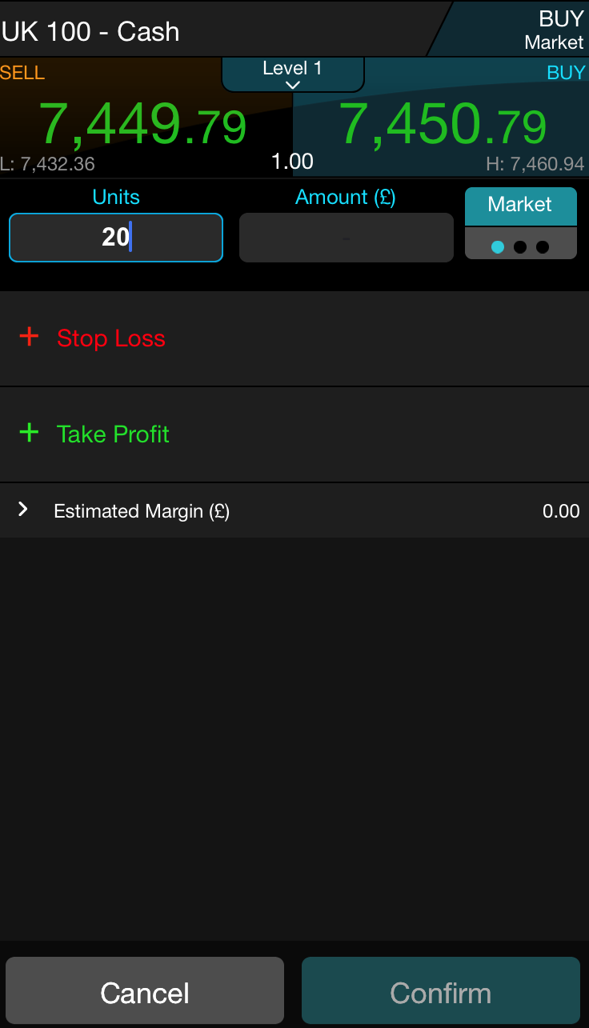

Recreate a very simple version of the order ticket on featuring the following:

* A sell price panel featuring the sell price in the top left (see CMC app).
* A buy price panel featuring the buy price in the top right (see CMC app).
* A units text input field and amount text input field (with units / amount heading labels). (See CMC app, below price panels)
* A blue confirm button in the style of the CMC app confirm button (See CMC app, bottom Confirm button)

## Must Have Requirements:

Receive Bitcoin price updates (BUY and SELL) and update the BUY and SELL prices and SPREAD* value on your order ticket accordingly.

Allow the user to input units (in Bitcoins) or amount (in GBP) into the units / amount text input fields mentioned above:

* If the user types in a value in the units field, the app should calculate the correct amount and populate the amount field also (BUY price * units value).
* If the user types in a value in the amount field, the app should calculate the correct units value and populate the units field also (BUY price / amount value).

The confirm button should be disabled when the units and amount fields are empty, and enabled once a value has been input and the keyboard has been dismissed.

## Nice To Have Requirements:

Some form of unit tests as part of the delivered project code.

Some indication of how the task progressed (e.g. a copy of the .git folder used for the task).

Some suggestions about how you could improve the code, functionality or UX of the delivered app.

## Implementation Notes:

For price updates, write a price service that polls the following URL every 15 seconds:

<https://blockchain.info/ticker>

This will return prices in JSON format. For more information see the simple API documentation here: <https://blockchain.info/api/exchange_rates_api>

When the price service has a completed polling the URL and received a response, parse the JSON and update the UI with the new bitcoin price (in GBP) and flash the BUY and SELL prices GREEN (whether it has changed or not) with an animation (see CMC app price update animation).

Units and amount input fields should accept update only valid numbers and numbers with up to two decimal places.

Where possible copy the CMC app UI design for the features that are being implemented (but you don’t need to create an exact representation as its quite a complex layout) e.g.

Colours, font size, layout.

On the price labels, numbers after the decimal point should be smaller than numbers before the decimal point. (See CMC app).

Text input fields should have a blue border when focussed, no border when not focussed and have curved edges.

Confirm button text and colour should be dimmed in disabled state.

*Calculate the spread by subtracting the SELL price from the BUY price. This is the small number between the two price panels as seen on the CMC app order ticket.